GLRLMS { mean of all 4 angles }

1. no variables excluded; no PCA; classes 1&2 and 3&4 lumped

Best classifier: KNN (k=10)

Accuracy = **79.2%**

AUC = 0.86

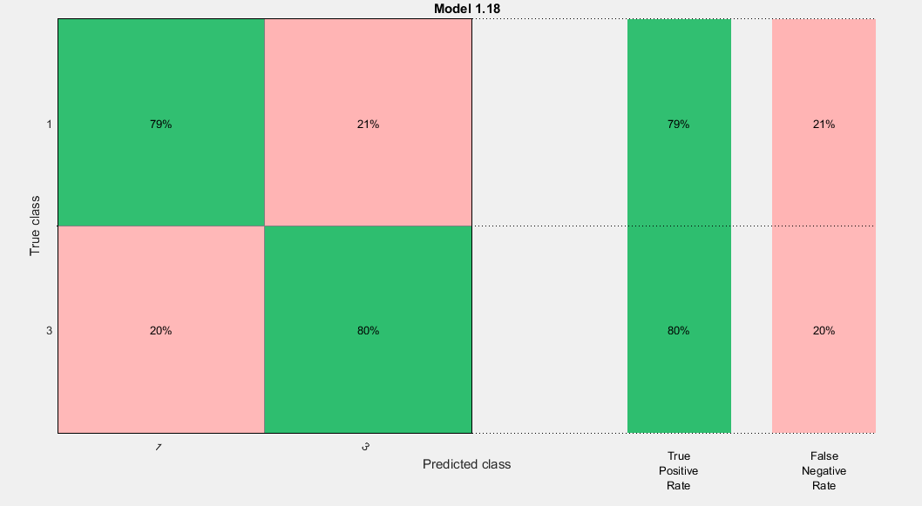

1. no variables excluded; no PCA; classes 1&2 and 3&4 lumped

Best classifier: KNN (k=10)

Accuracy = **80.5%**

AUC = 0.88

1. no variables excluded; no PCA; classes 1&2 and 3&4 lumped

Best classifier: KNN (k=10)

Accuracy = **81.8%**

AUC = 0.87

1. no variables excluded; no PCA; classes 1&2 and 3&4 lumped

Best classifier: Ensemble

Accuracy = **84.4%**

AUC = 0.88

1. no variables excluded; no PCA; classes 1&2 and 3&4 lumped

Best classifier: KNN (k=10)

Accuracy = **79.2%**

AUC = 0.84

**Average accuracy = 81.02%**

GLRLMS { only 45 degrees angle }

1. no variables excluded; no PCA; classes 1&2 and 3&4 lumped

Best classifier: KNN (k=1) & Ensemble

Accuracy = **84.4%**

AUC = 0.84

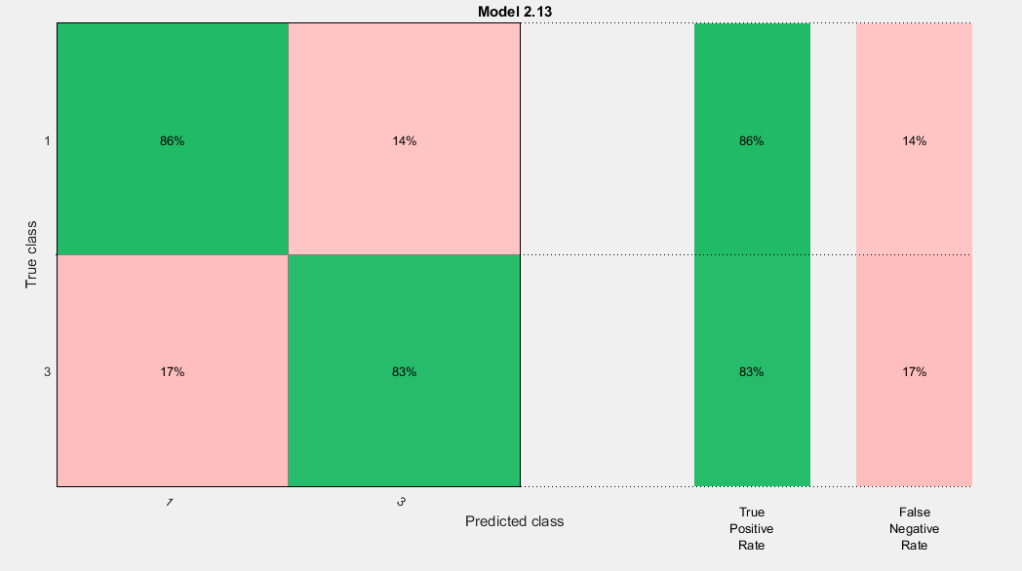

1. no variables excluded; no PCA; classes 1&2 and 3&4 lumped

Best classifier: Ensemble

Accuracy = **83.1%**

AUC = 0.86

1. no variables excluded; no PCA; classes 1&2 and 3&4 lumped

Best classifier: KNN (k=1)

Accuracy = **81.8%**

AUC = 0.81

1. no variables excluded; no PCA; classes 1&2 and 3&4 lumped

Best classifier: KNN (k=1)

Accuracy = **84.4%**

AUC = 0.84

1. no variables excluded; no PCA; classes 1&2 and 3&4 lumped

Best classifier: KNN (k=1)

Accuracy = **84.4%**

AUC = 0.84

**Average accuracy = 83.62%**